Terraform Challenge
Write a code using Terraform that deploys and achieves the following:-
- Create an EC2 Instance on AWS Cloud using the below-mentioned ubuntu AMI and instance_type. Or, (You can use of your choice as well) ami = "ami-0461b1436c9b3c1a3" instance_type = "t2.micro"
Lets create a folder called challenge and create a file called main.tf
provider "aws" {
region = "us-east-1"
}

resource "aws_instance" "ec2" {
ami = "ami-0461b1436c9b3c1a3"
instance_type = "t3.micro"

tags = {
Name = "Terraform-EC2"
}
}

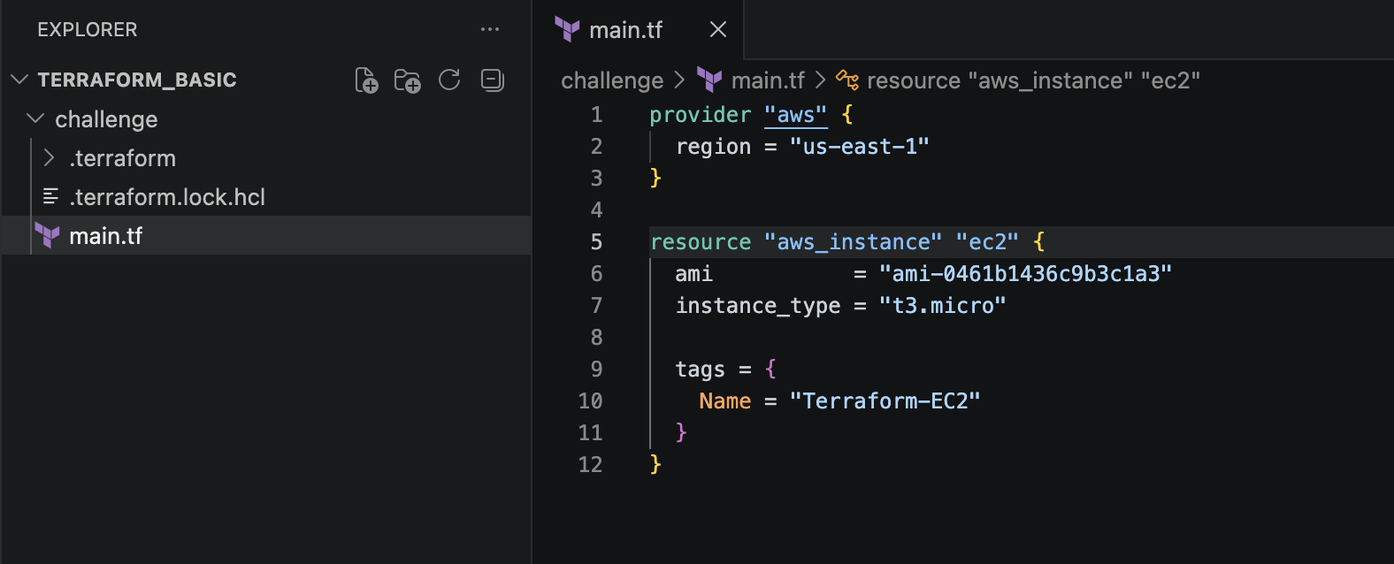
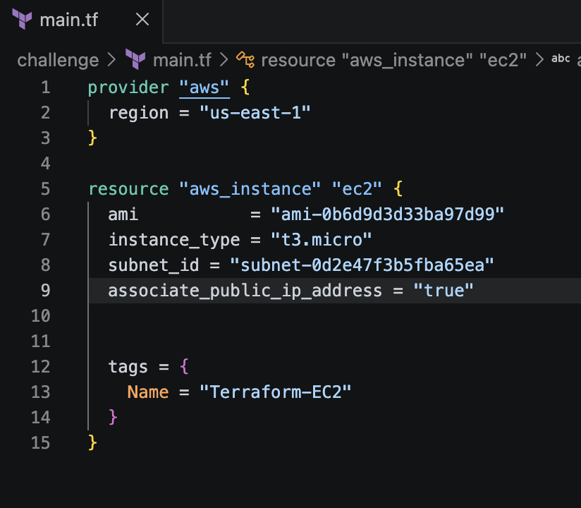
terraform init
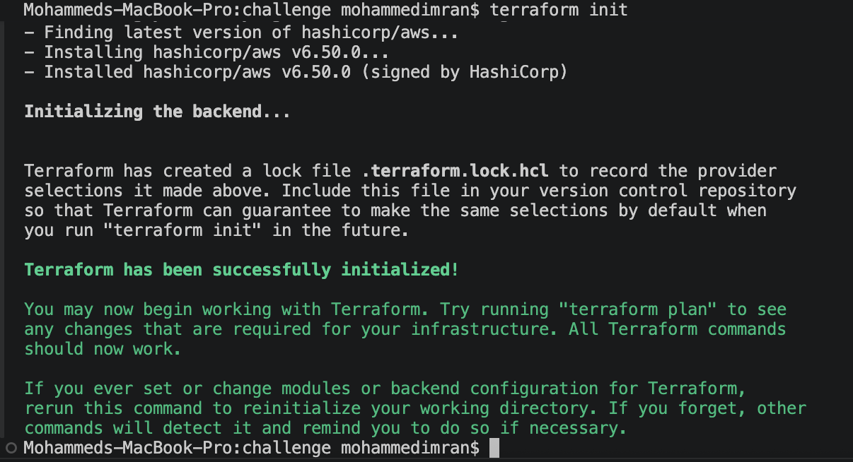
terraform plan
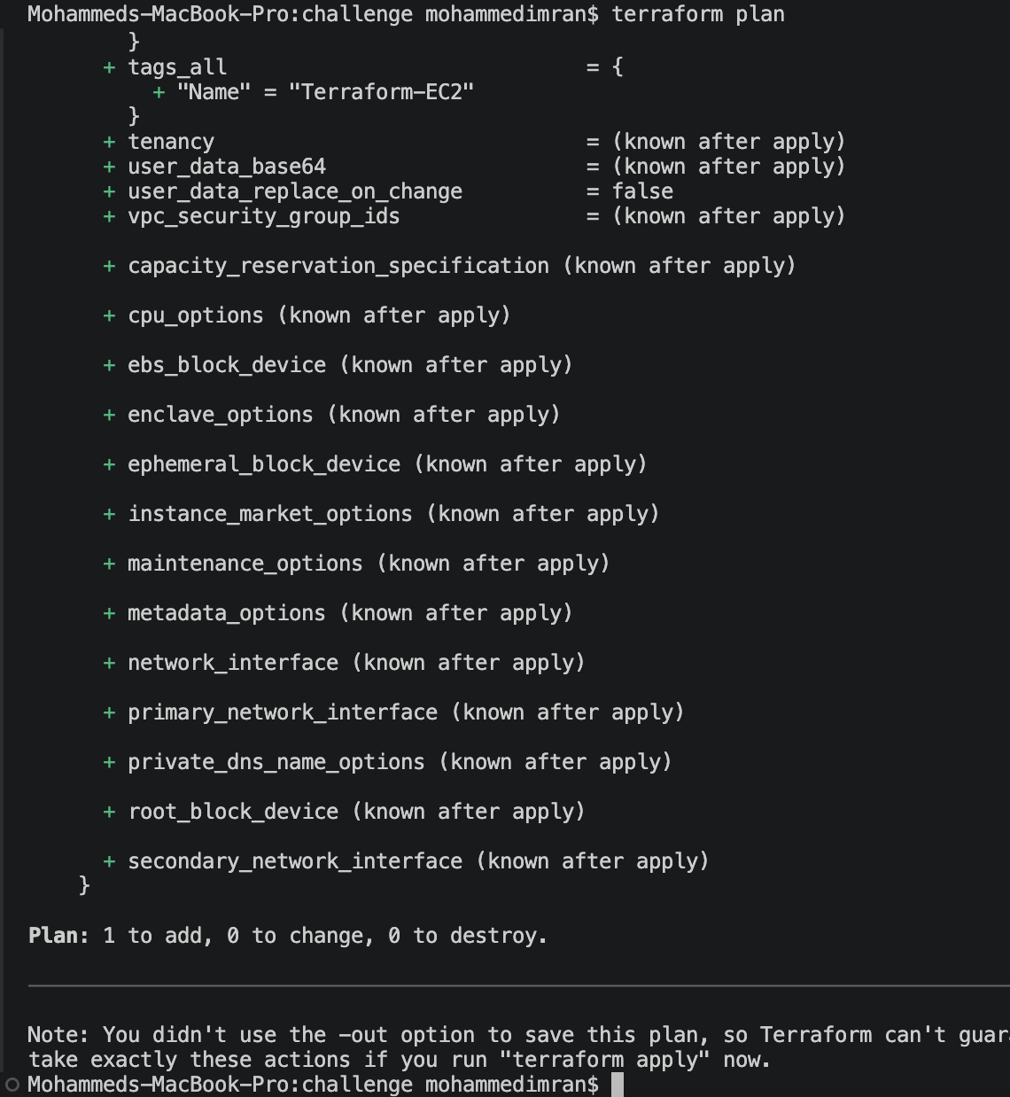
terraform apply
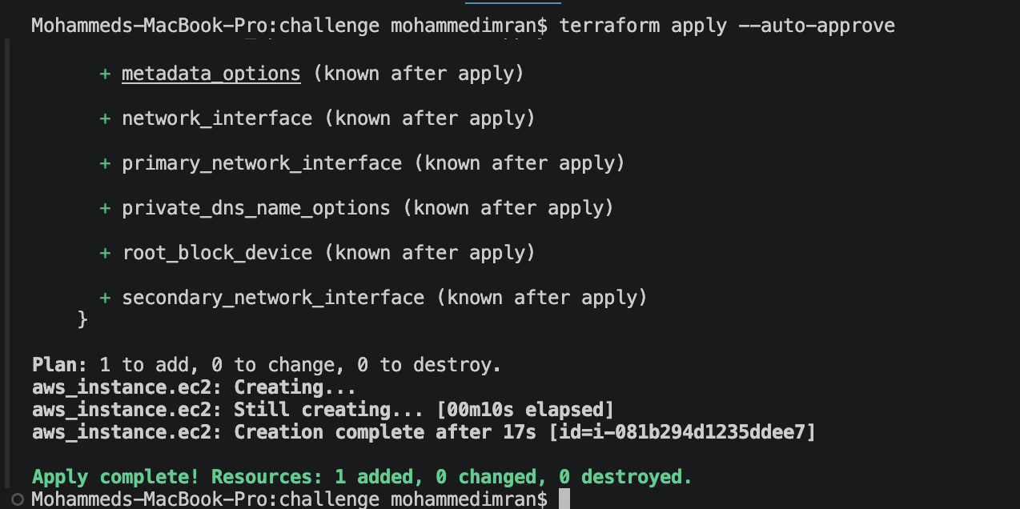
Confirm in AWS
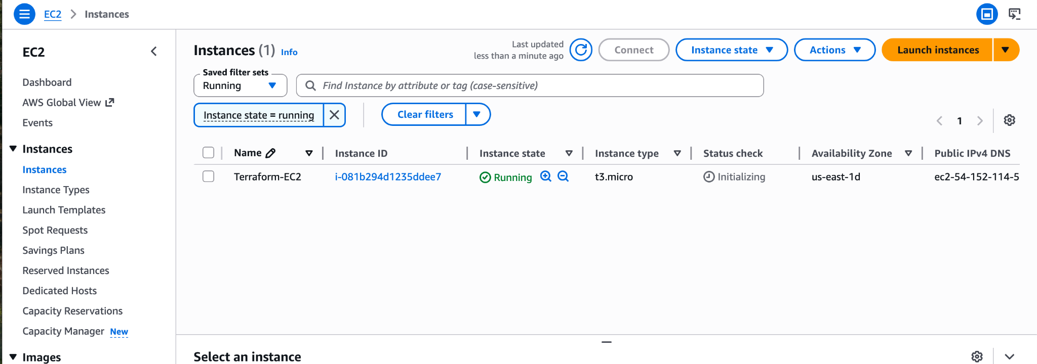
Instances has been successfully created

- Install a web server on the same EC2 Instance. The web server should listen on port 8080.

In the same main.tf file which we create earlier we are going to add a resource block for security groups and we will create and user data for installing nginx while creating a ec2 instance

RESOURCE BLOCK FOR SECURITY GROUPS(This can be optional has our vpc has default sg where all the ports are open).
resource "aws_security_group" "web_sg" {
name = "web-security-group"

ingress {
description = "SSH Access"
from_port = 22
to_port = 22
protocol = "tcp"
cidr_blocks = ["0.0.0.0/0"]
}

ingress {
description = "Web Server Port"
from_port = 8080
to_port = 8080
protocol = "tcp"
cidr_blocks = ["0.0.0.0/0"]
}

egress {
from_port = 0
to_port = 0
protocol = "-1"
cidr_blocks = ["0.0.0.0/0"]
}
}
This code is creating a security group in AWS called web-security-group.It decides who is allowed to connect to the server and what kind of traffic can go in or out.
The first ingress rule opens port 22 for SSH access and 8080 for whether the nginx web server is running or not. This lets you log into your EC2 instance remotely from your computer. Since the IP range is 0.0.0.0/0, it means anyone on the internet can try to access that port.
The egress rule allows the EC2 instance to send traffic out to the internet without restrictions.

USER-DATA
user_data = <<-EOF
#!/bin/bash

# Update packages
sudo apt update -y

# Install nginx
sudo apt install nginx -y

# Create webpage
sudo tee /var/www/html/index.html > /dev/null <<HTML
<h1>Nginx Running on Port 8080</h1>
HTML

# Configure nginx to listen on 8080
sudo tee /etc/nginx/sites-available/default > /dev/null <<EOL
server {
listen 8080;

root /var/www/html;
index index.html;
}
EOL

# Restart nginx
sudo systemctl restart nginx
sudo systemctl enable nginx
EOF
This code is automatically setting up a web server when the EC2 instance starts. First, it updates the system packages and installs Nginx. Then it creates a simple webpage with the message “Nginx Running on Port 8080”. After that, it changes the Nginx configuration so the server listens on port 8080 instead of the default port. Finally, it restarts Nginx and enables it to start automatically whenever the server reboots.

main.tf file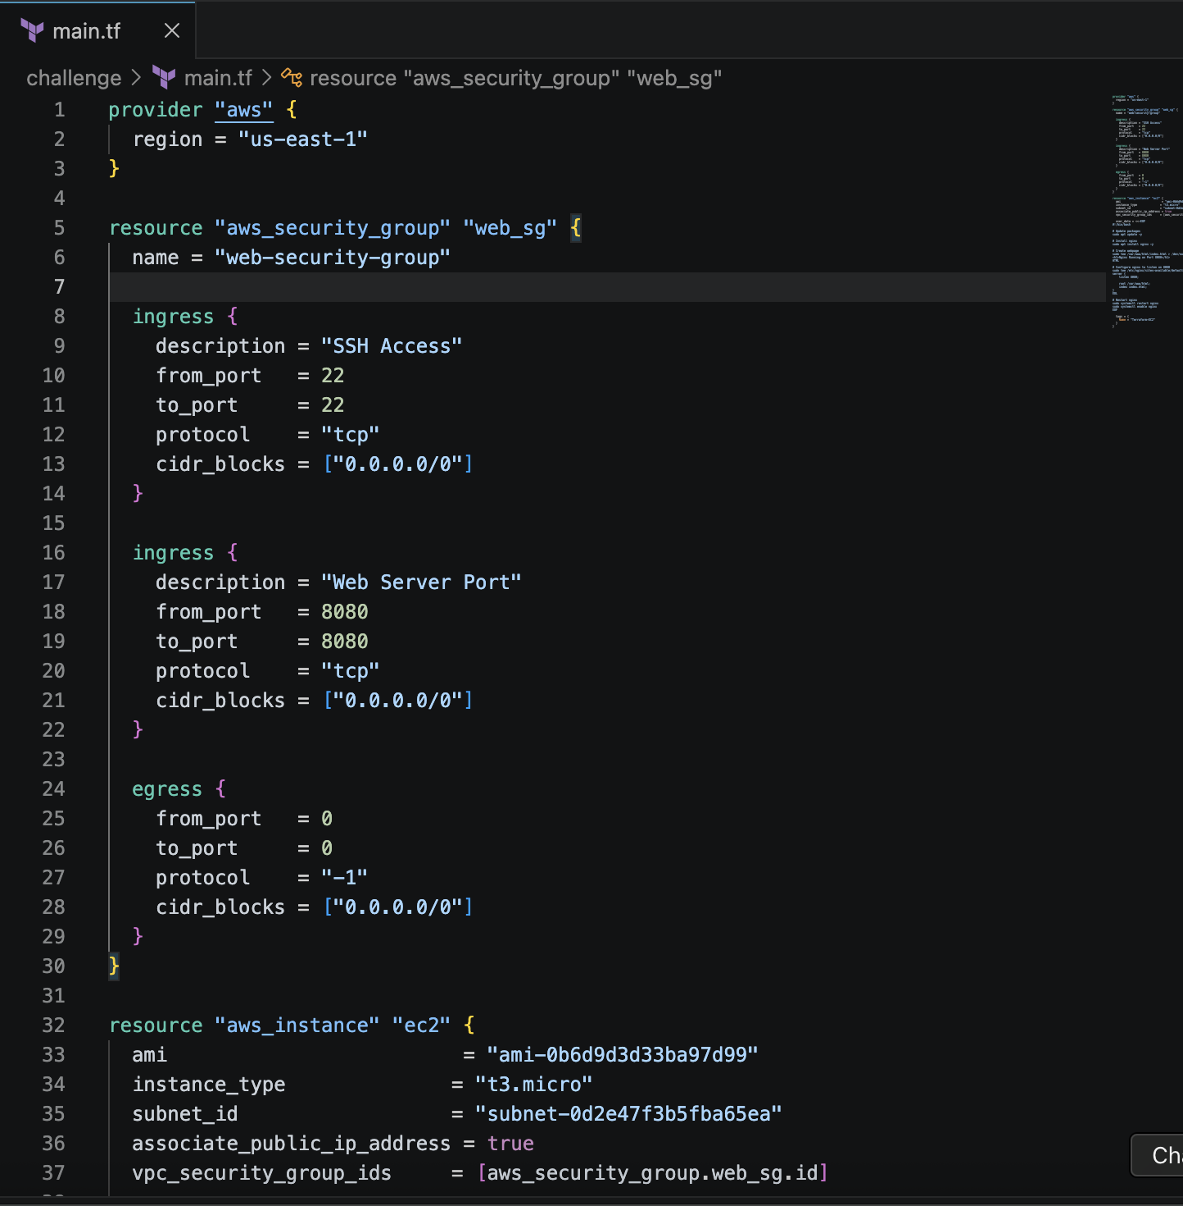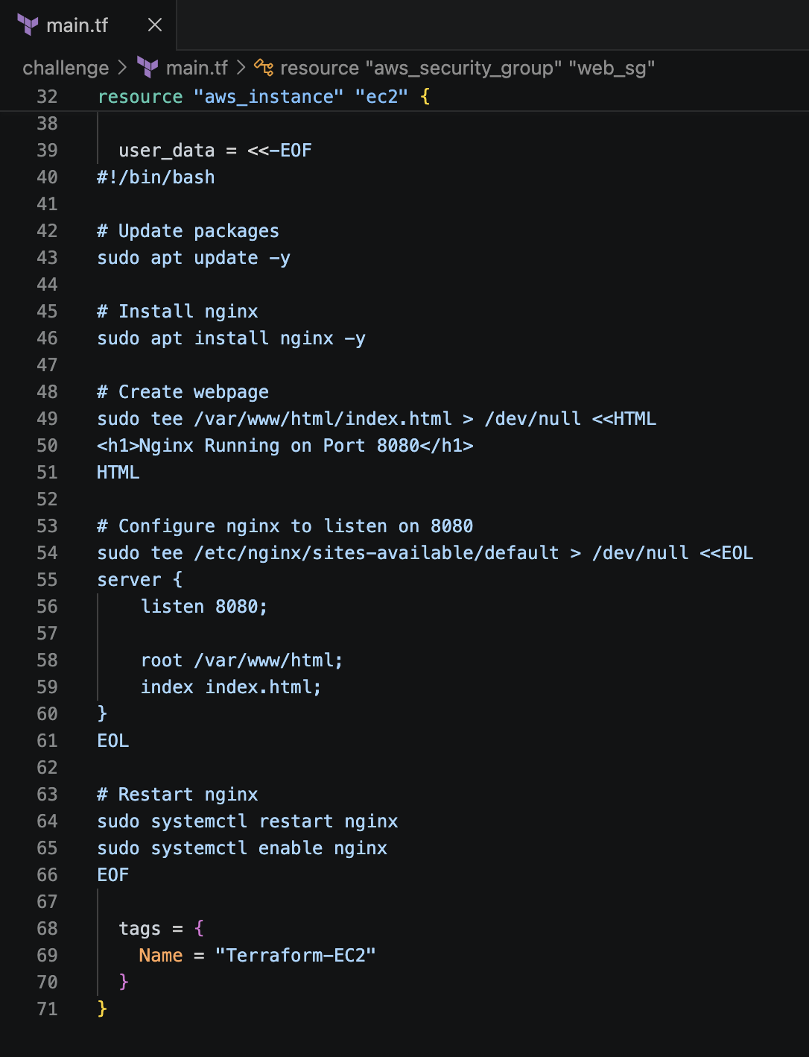

terraform init, terraform plan, and terraform apply
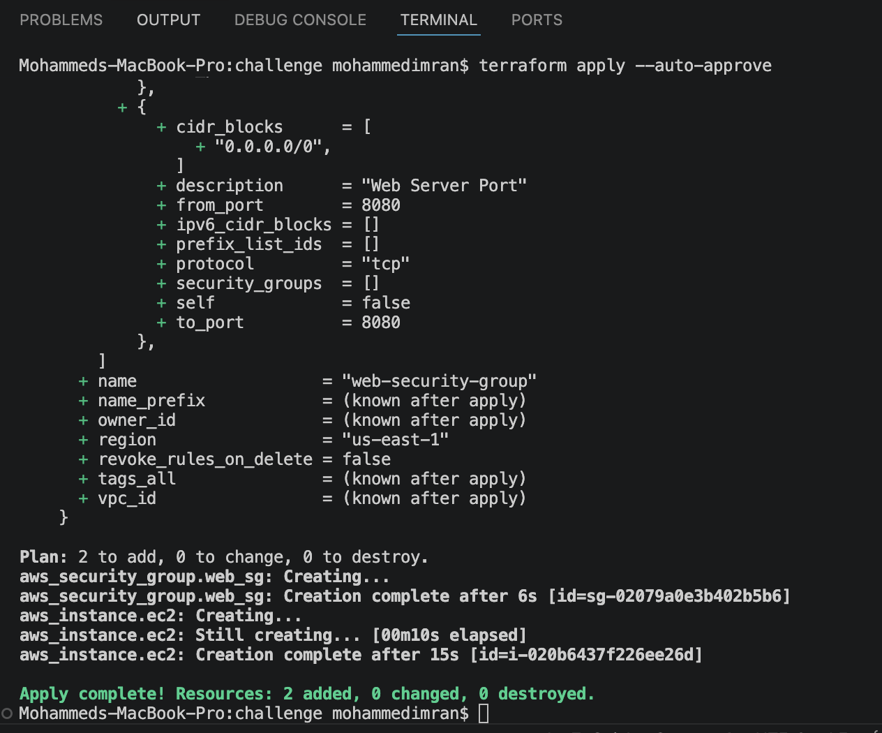
Lets check in AWS now
Ec2 created
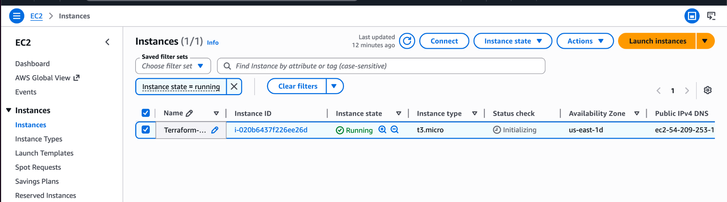
Lets check by connecting
Systemctl status nginx
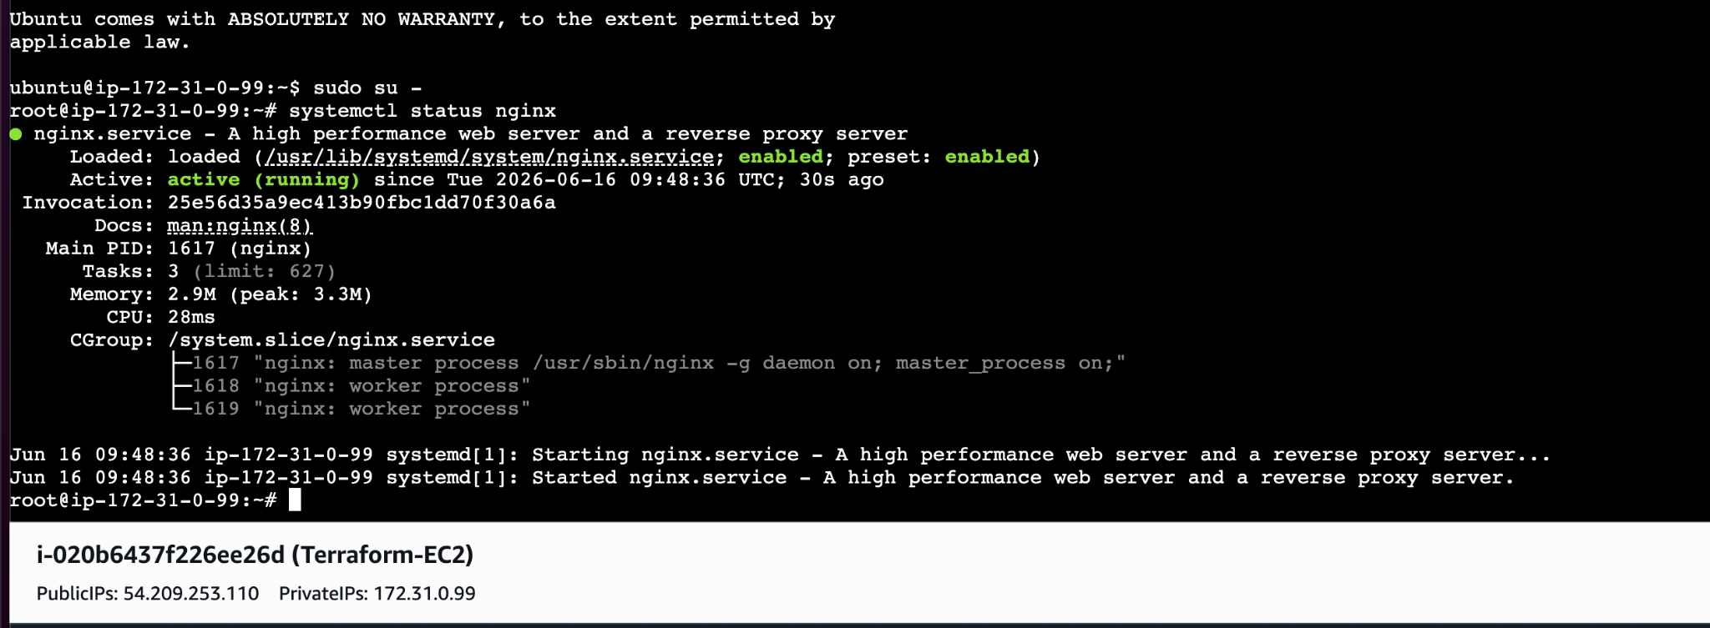
Lets check by using <ip addrtess>:8080
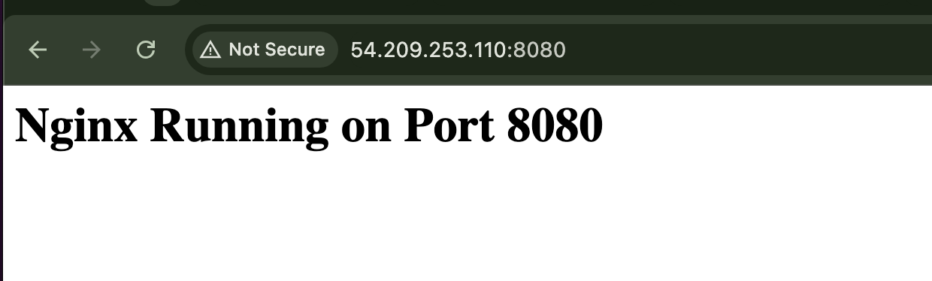

- Create a Docker-compose file for the project:https://github.com/betawins/cricbuzz-docker-hello-world.gitand point it to port 8000.
First lets create a security group and open the port like what we need. The changes we are doing is in our main.tf file
In Main.tf file we will opening a security port for Docker APP
Ingress {
Description - “Docker App”
From_port = 8000
T0_port 8000
Protocol = “tcp”
Cidr_blocks = [0.0.0.0/0]
}
This is the only change done in main.tf file
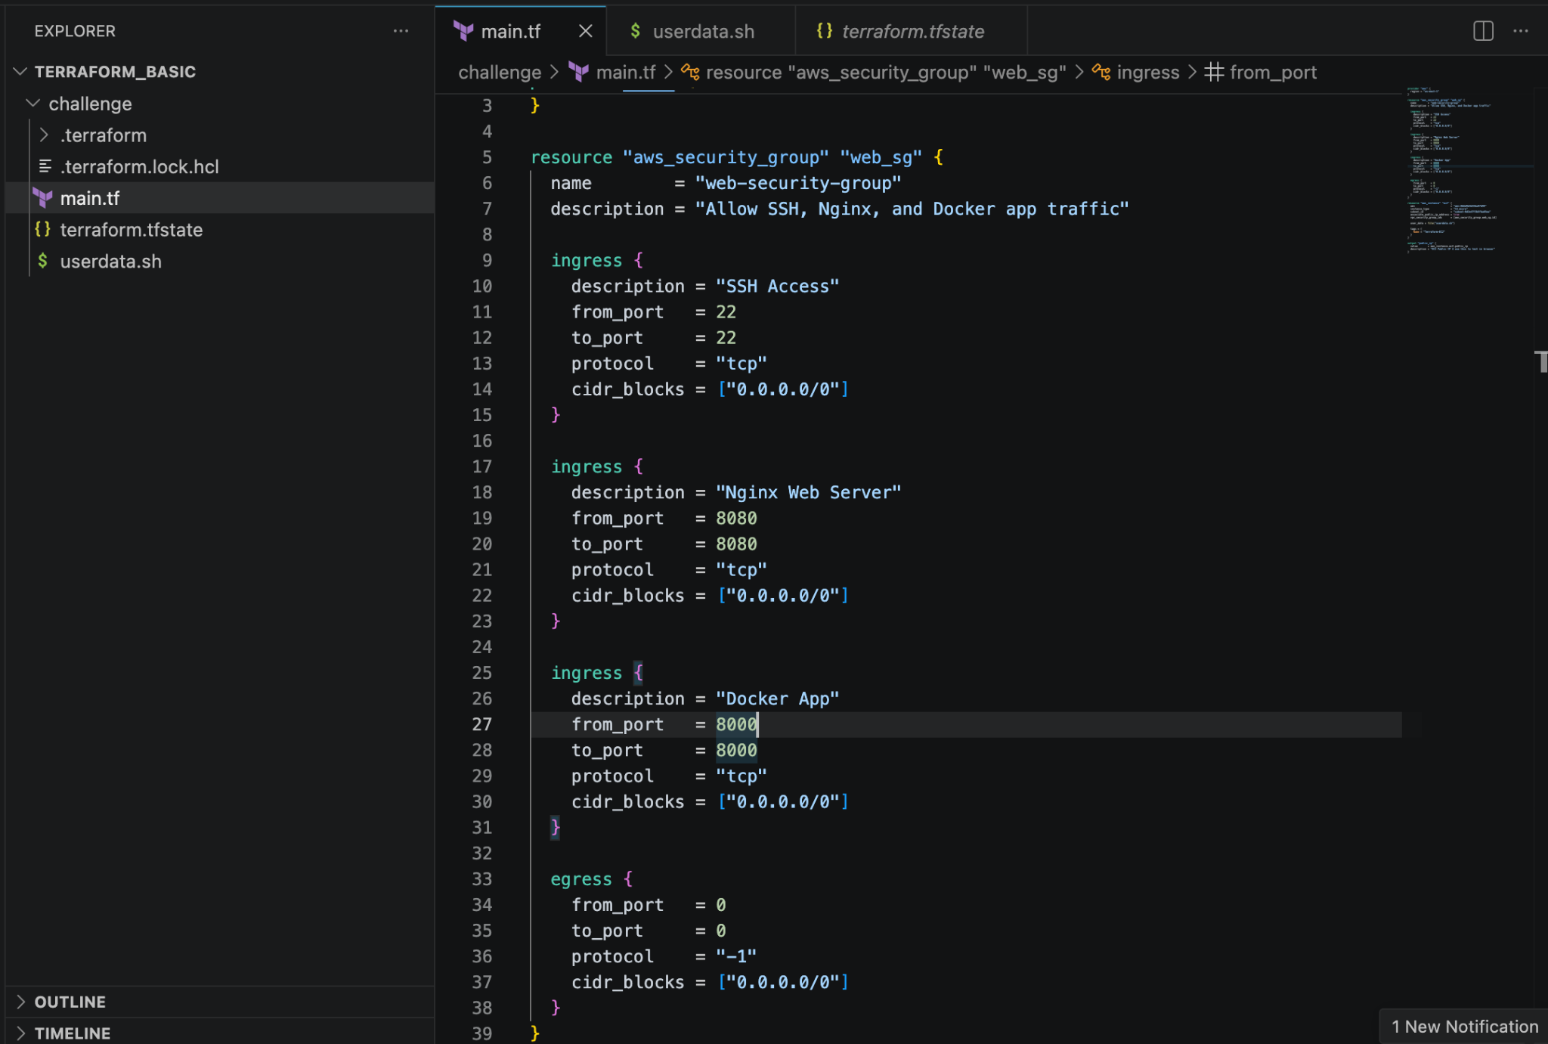
Now I'm using/adding/creating another file called userdata.sh as in the previous question I used userdata in the main.tf file itself but for this question I created a new file called userdata.sh for not making the code looks clumsy.
For this the changes i made in the main.tf file is just calling the userdata.sh file
In resource block instead of userdata ⇒ i used user_data = file(“userdata.sh”)
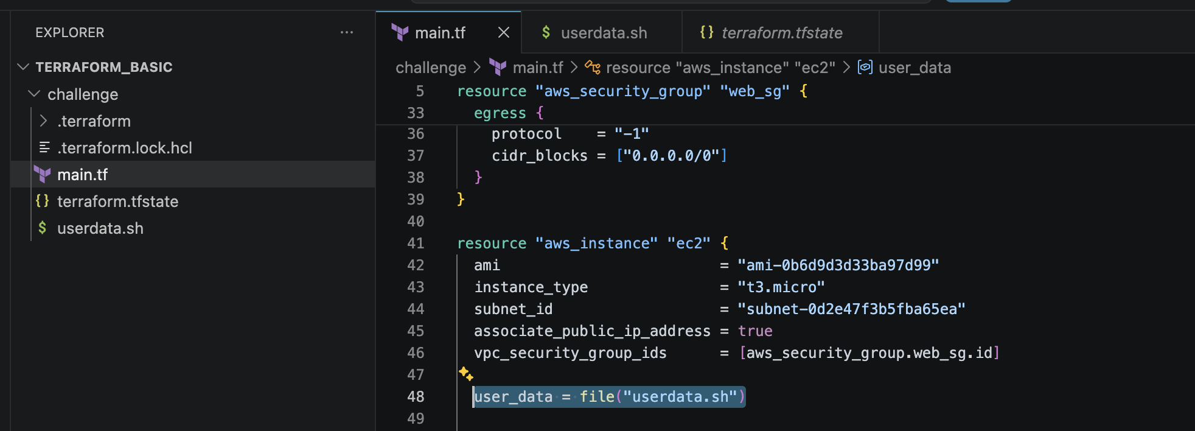
The changes I made in userdata from the previous question are downloading git, docker,docker compose, go language and its dependencies.

Script:
port DEBIAN_FRONTEND=noninteractive
exec > /var/log/userdata.log 2>&1

echo “=== Step 1: Install nginx, git, curl, golang ===”
apt-get update -y
apt-get install -y nginx git curl ca-certificates gnupg golang-go

echo “=== Step 2: Configure Nginx on port 8080 ===”
tee /etc/nginx/sites-available/default > /dev/null <<‘EOL’
server {
listen 8080;
root /var/www/html;
index index.html;
}
EOL
echo “<h1>Nginx Running on Port 8080</h1>” > /var/www/html/index.html
nginx -t && systemctl restart nginx && systemctl enable nginx

echo “=== Step 3: Install Docker CE ===”
install -m 0755 -d /etc/apt/keyrings
curl -fsSL https://download.docker.com/linux/ubuntu/gpg \
| gpg --dearmor -o /etc/apt/keyrings/docker.gpg
chmod a+r /etc/apt/keyrings/docker.gpg
echo \
“deb [arch=$(dpkg --print-architecture) signed-by=/etc/apt/keyrings/docker.gpg] \
https://download.docker.com/linux/ubuntu \
$(. /etc/os-release && echo “$VERSION_CODENAME”) stable” \
| tee /etc/apt/sources.list.d/docker.list > /dev/null
apt-get update -y
apt-get install -y docker-ce docker-ce-cli containerd.io docker-compose-plugin
systemctl enable docker
systemctl start docker

echo “=== Step 4: Clone repo ===”
cd /home/ubuntu
git clone https://github.com/betawins/cricbuzz-docker-hello-world.git
cd cricbuzz-docker-hello-world

echo “=== Step 5: Build static Go binary ===”
export HOME=/root
CGO_ENABLED=0 GOOS=linux GOARCH=amd64 go build -a -ldflags=‘-extldflags=-static’ -o hello_world .

echo “=== Step 6: Write docker-compose.yml ===”
cat > docker-compose.yml <<‘COMPOSE’
services:
cricbuzz-app:
build:
context: .
dockerfile: Dockerfile
container_name: cricbuzz-container
ports:
- “8000:8080"
restart: unless-stopped
COMPOSE

echo “=== Step 7: Build and start container ===”
docker compose build --no-cache
docker compose up -d

echo “=== DONE ===”
docker ps
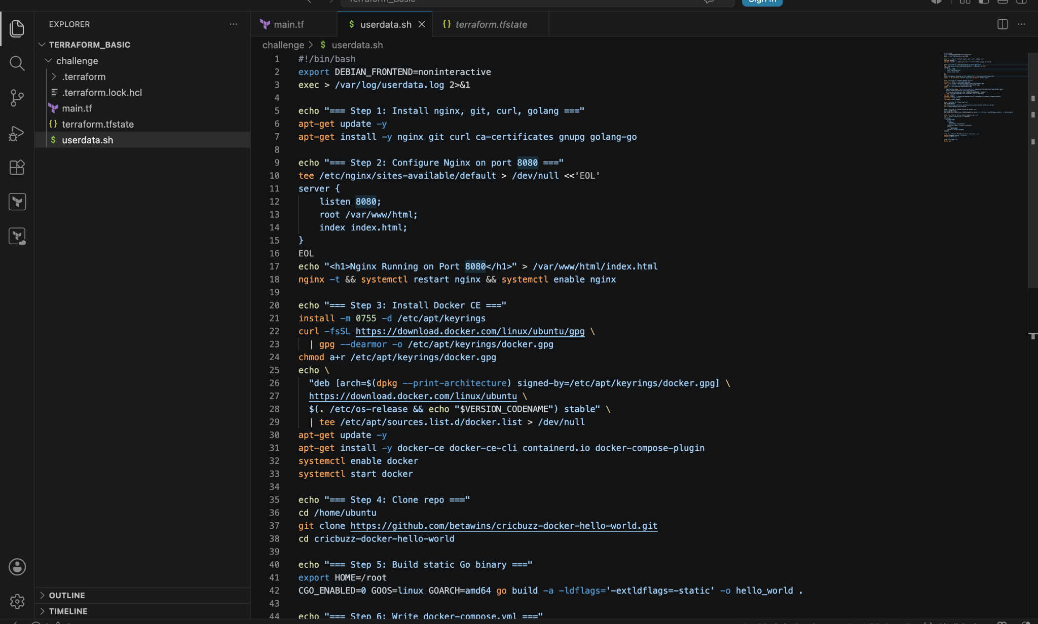
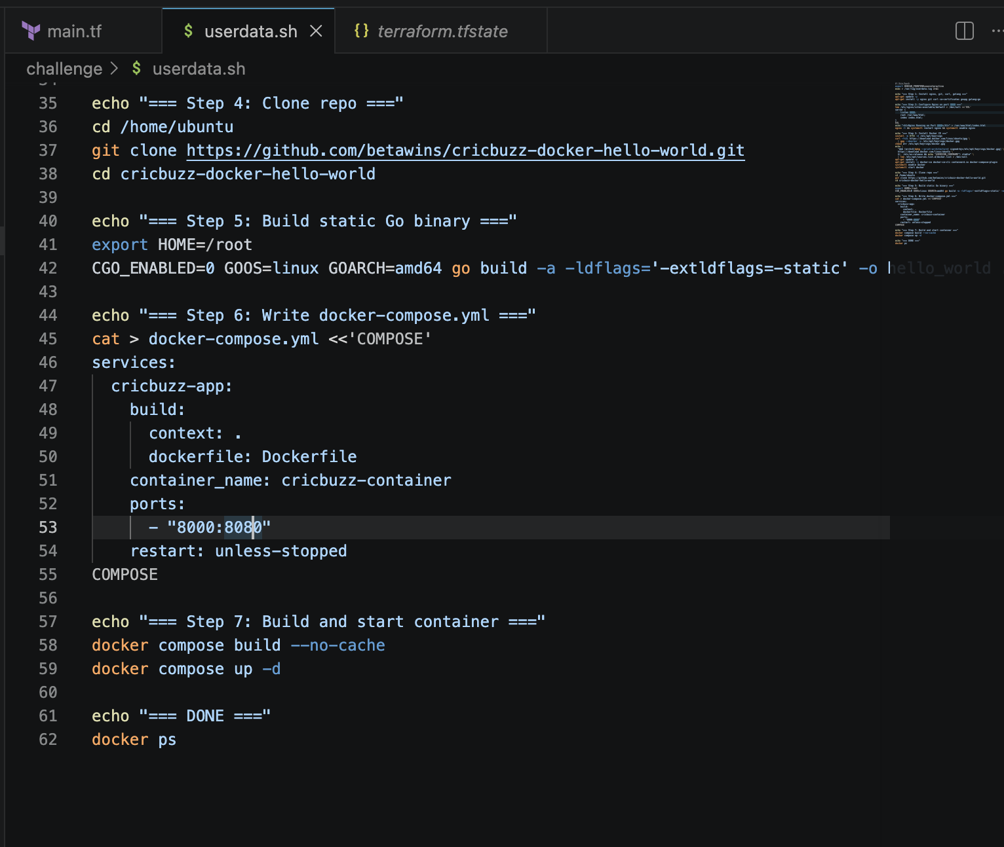
So lets understand whats happening in the above code

#!/bin/bash
export DEBIAN_FRONTEND=noninteractive
exec > /var/log/userdata.log 2>&1
- #!/bin/bash — tells Linux "run this file using bash shell"
- DEBIAN_FRONTEND=noninteractive — tells apt-get "don't ask me any questions, just install silently". Without this, apt sometimes stops and waits for input which kills the script
- exec > /var/log/userdata.log 2>&1 — saves ALL output (success and errors) to a log file so we can debug later. 2>&1 means "also save error messages, not just normal output"

Step 1 — Install Packages

apt-get update -y
apt-get install -y nginx git curl ca-certificates gnupg
- apt-get update — refreshes the list of available packages from internet (like refreshing an app store)
- apt-get install -y — installs packages, -y means "say yes to everything automatically"
- nginx — the web server we need
- git — needed to clone the GitHub repo
- curl — needed to download Docker's GPG key
- ca-certificates and gnupg — needed to verify Docker's download is authentic and safe

Step 2 — Configure Nginx

tee /etc/nginx/sites-available/default > /dev/null <<'EOL'
server {
listen 8080;
root /var/www/html;
index index.html;
}
EOL
- tee — writes text into a file
- /etc/nginx/sites-available/default — this is nginx's main config file
- > /dev/null — hides the output from screen (we don't need to see it)
- <<'EOL' ... EOL — everything between these two EOL markers gets written into the file
- listen 8080 — tells nginx to listen on port 8080 instead of default port 80
- root /var/www/html — the folder where nginx looks for web files
- index index.html — the default file to show when someone visits

echo "<h1>Nginx Running on Port 8080</h1>" > /var/www/html/index.html
- Creates a simple HTML page so we can see something when we visit port 8080 in browser

nginx -t && systemctl restart nginx && systemctl enable nginx
- nginx -t — tests the config file for errors
- && — only run the next command if the previous one succeeded
- systemctl restart nginx — restarts nginx to apply the new config
- systemctl enable nginx — makes nginx start automatically if EC2 reboots

Step 3 — Install Docker

install -m 0755 -d /etc/apt/keyrings
curl -fsSL https://download.docker.com/linux/ubuntu/gpg \
| gpg --dearmor -o /etc/apt/keyrings/docker.gpg
chmod a+r /etc/apt/keyrings/docker.gpg
- install -m 0755 -d /etc/apt/keyrings — creates a secure folder to store Docker's security key
- curl -fsSL ... — downloads Docker's GPG key (a digital signature to verify Docker is genuine)
- | gpg --dearmor — converts the key into a format Ubuntu understands
- -o /etc/apt/keyrings/docker.gpg — saves it to the keyrings folder
- chmod a+r — makes the key file readable

echo \
"deb [arch=$(dpkg --print-architecture) signed-by=/etc/apt/keyrings/docker.gpg] \
https://download.docker.com/linux/ubuntu \
$(. /etc/os-release && echo "$VERSION_CODENAME") stable" \
| tee /etc/apt/sources.list.d/docker.list > /dev/null
- This adds Docker's official download source to Ubuntu's package list
- arch=$(dpkg --print-architecture) — automatically detects if machine is amd64, arm64 etc
- VERSION_CODENAME — automatically detects Ubuntu version name (e.g. "jammy", "resolute")
- Without this, apt-get install docker-ce would fail because Ubuntu doesn't know where to find Docker CE

apt-get update -y
apt-get install -y docker-ce docker-ce-cli containerd.io docker-compose-plugin
systemctl enable docker
systemctl start docker
- apt-get update — refreshes package list again, now including Docker's source
- docker-ce — the main Docker engine
- docker-ce-cli — the docker command line tool
- containerd.io — the container runtime that Docker uses underneath
- docker-compose-plugin — gives us the docker compose command
- systemctl enable — auto-start Docker on reboot
- systemctl start — start Docker right now

Step 4 — Clone the Repo

cd /home/ubuntu
git clone https://github.com/betawins/cricbuzz-docker-hello-world.git
cd cricbuzz-docker-hello-world
- cd /home/ubuntu — go to ubuntu user's home folder
- git clone — downloads the entire project from GitHub into a new folder
- cd cricbuzz-docker-hello-world — go inside that downloaded folder

Step 5 — Override Dockerfile (The Most Important Step)

cat > Dockerfile <<'DOCKERFILE'
FROM golang:1.21-alpine AS builder
WORKDIR /app
COPY go.mod go.sum ./
RUN go mod download
COPY . .
RUN CGO_ENABLED=0 GOOS=linux go build -a -ldflags='-extldflags=-static' -o hello_world .

FROM scratch
COPY --from=builder /app/hello_world /hello_world
ENV GIN_MODE=release
EXPOSE 8080
ENTRYPOINT ["/hello_world"]
DOCKERFILE
This is a two-stage Dockerfile — think of it as two separate rooms:
Stage 1 — Builder room:
- FROM golang:1.21-alpine AS builder — start with a container that already has Go installed, call it "builder"
- WORKDIR /app — set working directory inside container to /app
- COPY go.mod go.sum ./ — copy dependency files first (faster rebuilds)
- RUN go mod download — download all Go dependencies
- COPY . . — copy all project files into container
- CGO_ENABLED=0 — disable C dependencies
- GOOS=linux GOARCH=amd64 — build specifically for Linux 64-bit
- -ldflags='-extldflags=-static' — make the binary fully self-contained (no external libraries needed)
- -o hello_world — name the output file "hello_world"
Stage 2 — Final room:
- FROM scratch — start with a completely empty container (no OS, nothing)
- COPY --from=builder /app/hello_world /hello_world — copy ONLY the binary from builder room
- ENV GIN_MODE=release — set the app to run in production mode
- EXPOSE 8080 — tell Docker the app listens on port 8080
- ENTRYPOINT ["/hello_world"] — run this binary when container starts
Why two stages? The builder room is ~400MB (Go compiler etc). The final image is only ~20MB because we throw away everything except the compiled binary.

Step 6 — Write docker-compose.yml

cat > docker-compose.yml <<'COMPOSE'
services:
cricbuzz-app:
build:
context: .
dockerfile: Dockerfile
container_name: cricbuzz-container
ports:
- "8000:8080"
restart: unless-stopped
COMPOSE
- services — defines what containers to run
- cricbuzz-app — the name of our service
- build: context: . — build the image from current folder
- dockerfile: Dockerfile — use our Dockerfile
- container_name: cricbuzz-container — name the running container
- ports: "8000:8080" — map host port 8000 → container port 8080. Think of it like a receptionist: "anyone calling 8000 gets forwarded to 8080 inside"
- restart: unless-stopped — if container crashes, restart it automatically

Step 7 — Build and Start
docker compose build --no-cache
docker compose up -d
docker ps
- docker compose build --no-cache — builds the Docker image fresh from scratch, ignoring any cached layers
- docker compose up -d — starts the container, -d means "detached" (runs in background, doesn't block terminal)
- docker ps — shows running containers to confirm it worked

Summary — The Full Flow
EC2 starts
↓
Install nginx → configure port 8080 → start nginx
↓
Install Docker CE (official, not docker.io)
↓
Clone GitHub repo
↓
Override Dockerfile with multi-stage build
↓
docker compose build → Go compiles inside Docker (no Go needed on host)
↓
docker compose up → container starts, app runs on port 8000
↓
Result: nginx on :8080 ✅ cricbuzz app on :8000 ✅

terraform init ⇒ the reason to do this is we have new block added in our resource block in main.tf
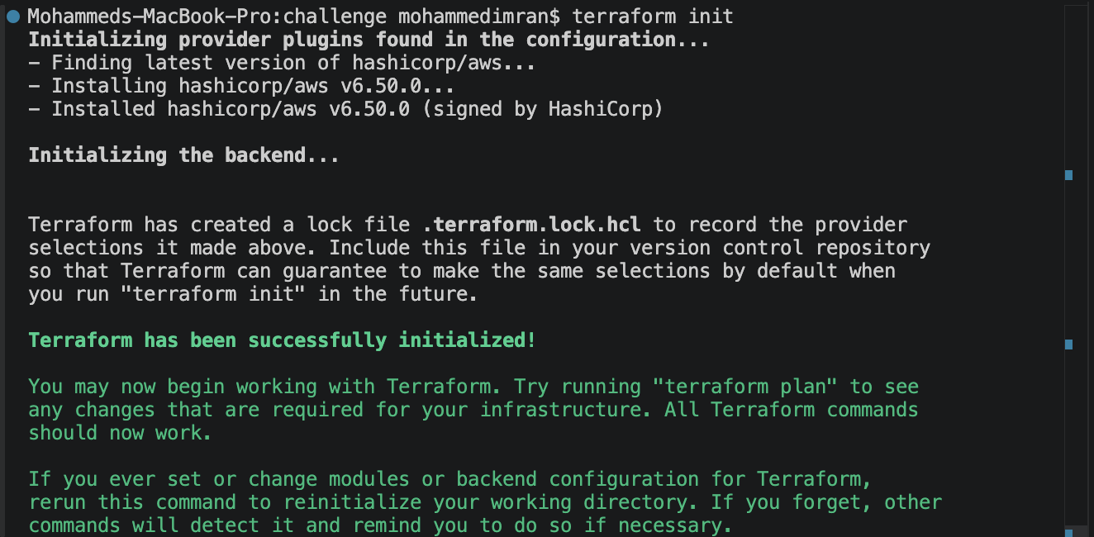
terraform apply
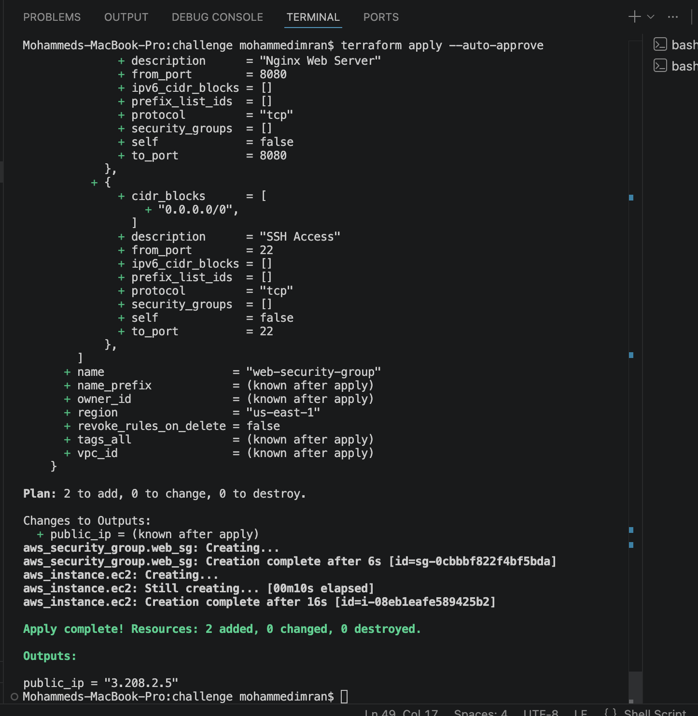
Now lets check if our ec2 has been created
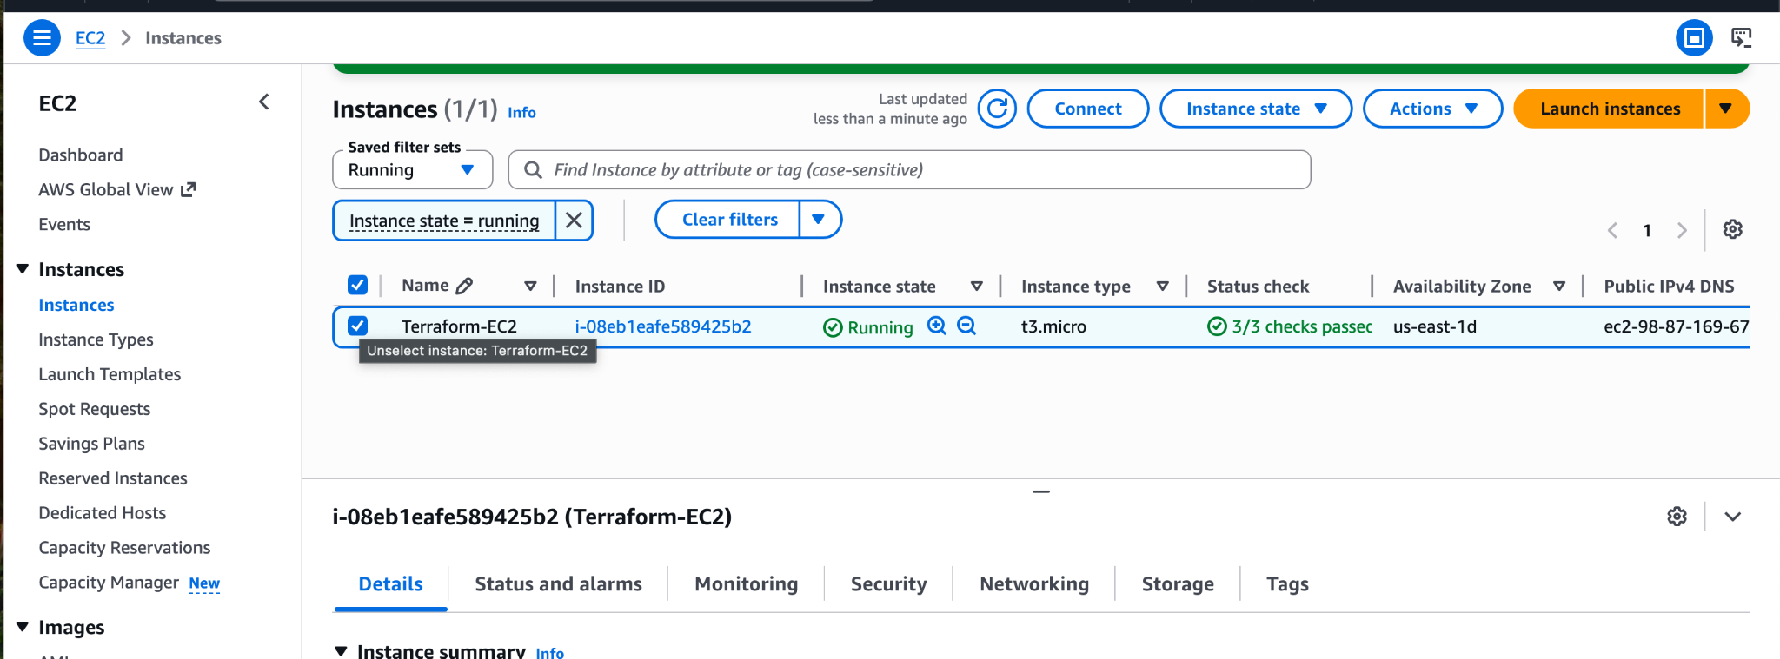
Lets check if our services what we downloaded in the script in working or not
Instance→ec2 connect
Check if nginx is active
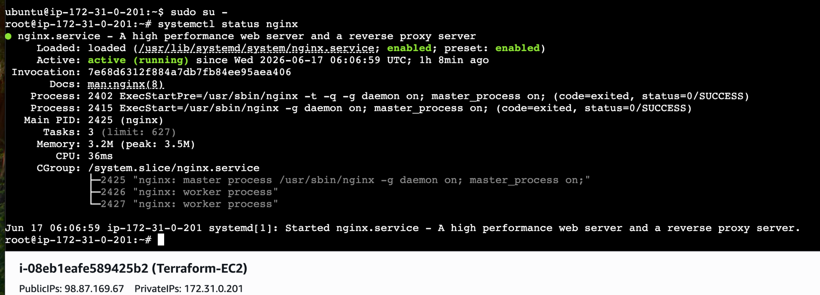
Checking if docker is active
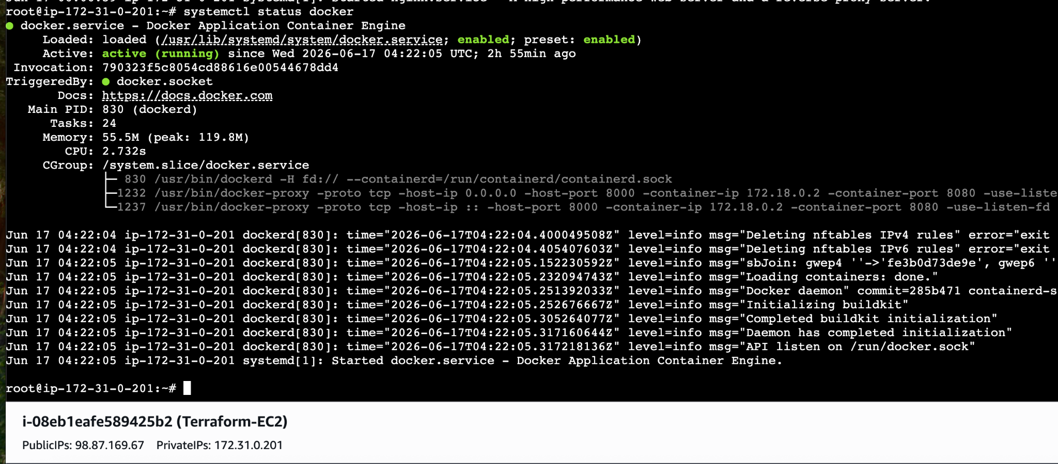

Lets check in browser if everything is working or not by using two different ports
<publicip>:8080
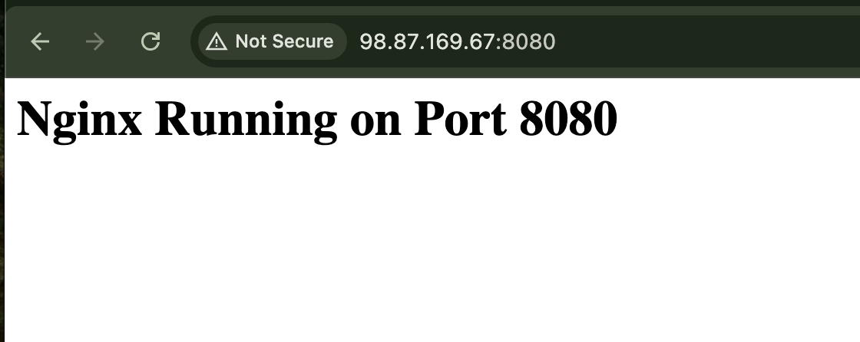<publicip>:8000
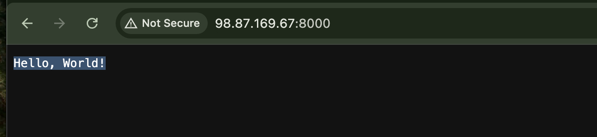
EC2 Instance
├── Nginx web server → port 8080 ✅
└── Docker container → port 8000 ✅
└── Go app (cricbuzz-docker-hello-world)
└── responds with "Hello, World!"

- Make the web server point to the above service so that 8080 returns the response from the Docker service.
This means Nginx should act as a reverse proxy — when someone visits port 8080, Nginx forwards the request to the Docker app on port 8000 and returns its response.

We will the replacing index.html part in nginx block with
location / {
proxy_pass http://localhost:8000;
proxy_set_header Host $host;
proxy_set_header X-Real-IP $remote_addr;
This should be added in place of index.html

In Question 2: Here Nginx was acting as a file server — just showing an HTML file it stored locally.
Now Nginx is acting as a reverse proxy — forwarding requests to Docker. So we don't need a local HTML file anymore because Nginx is no longer serving files, it's just passing traffic through to port 8000.
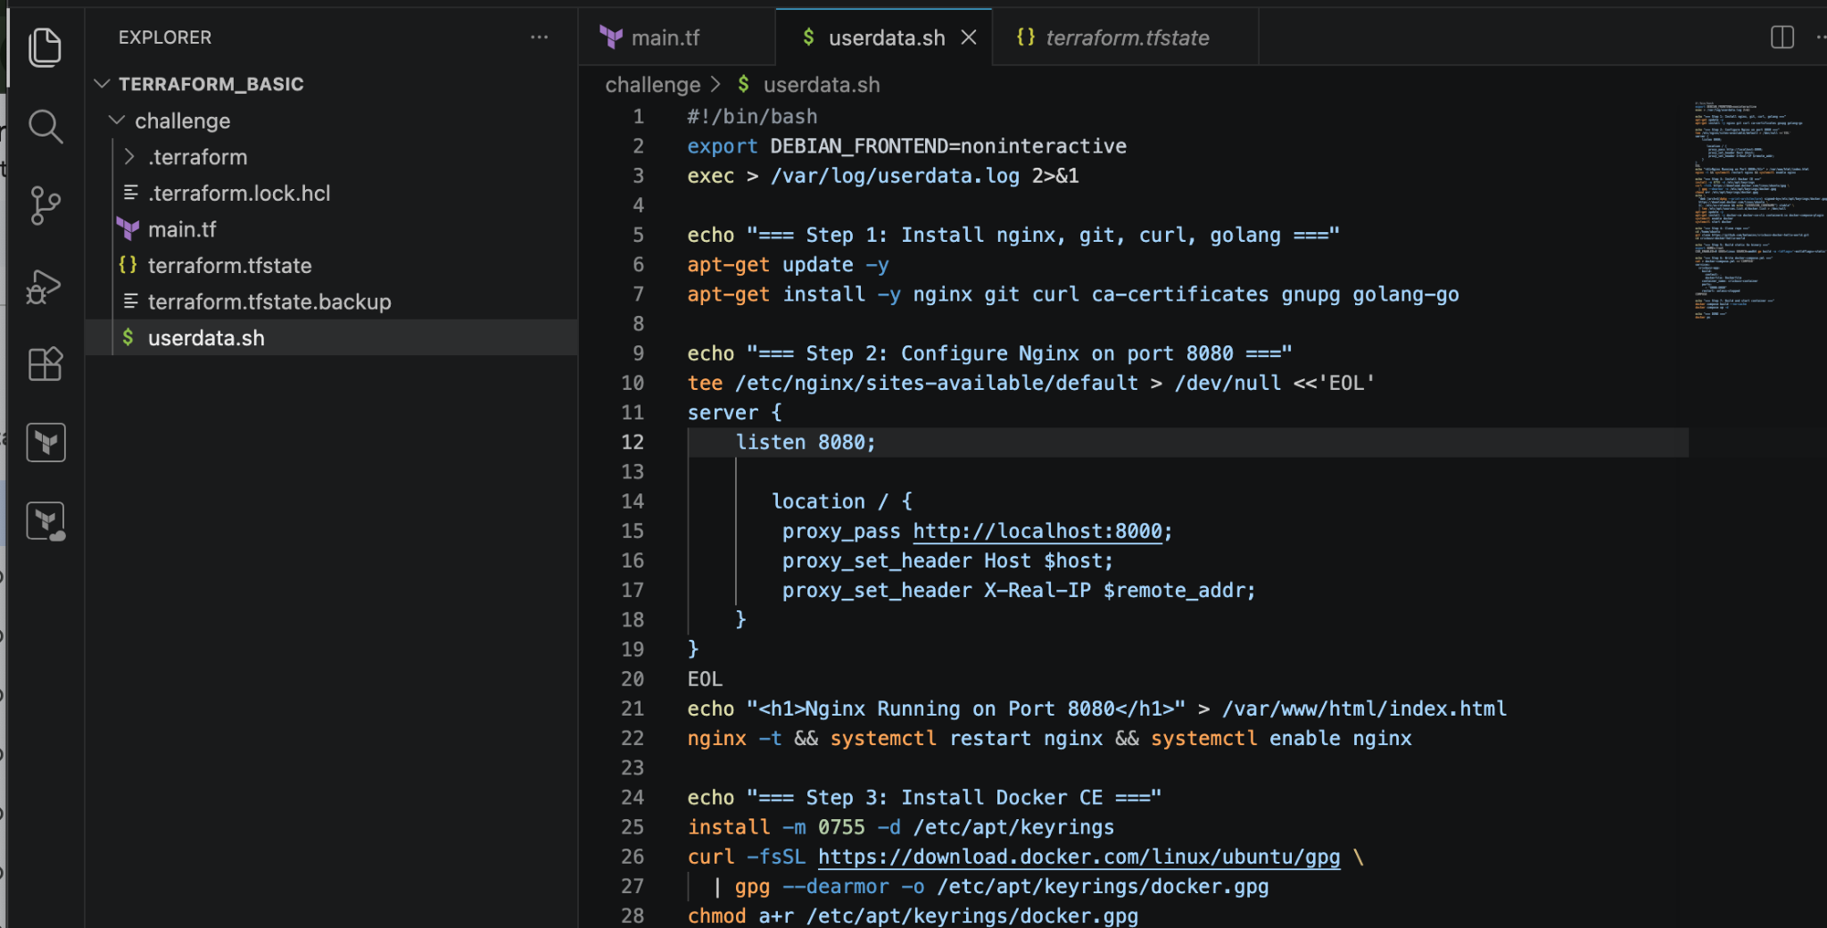
terraform destroy + terraform apply ⇒ This creates a fresh EC2 with the correct userdata. Clean and reliable.
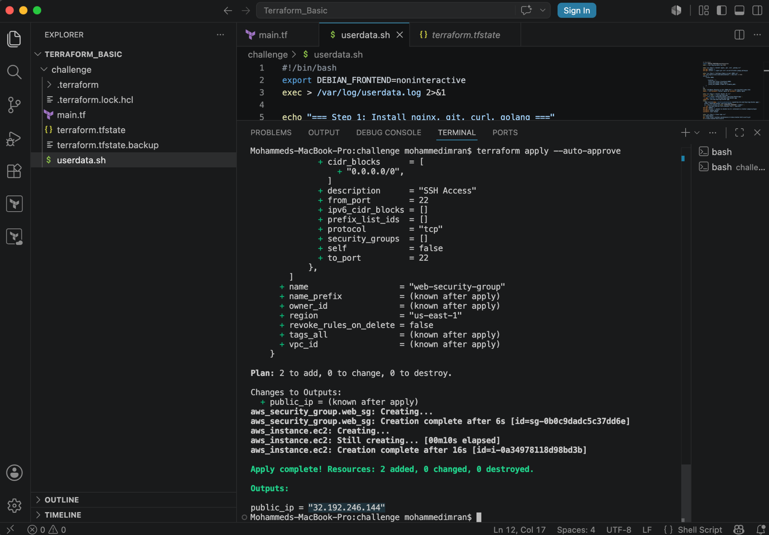
Ip generated: 32.192.246.144
Lets check if what we have done is working as it should be or not.
32.192.246.144:8080
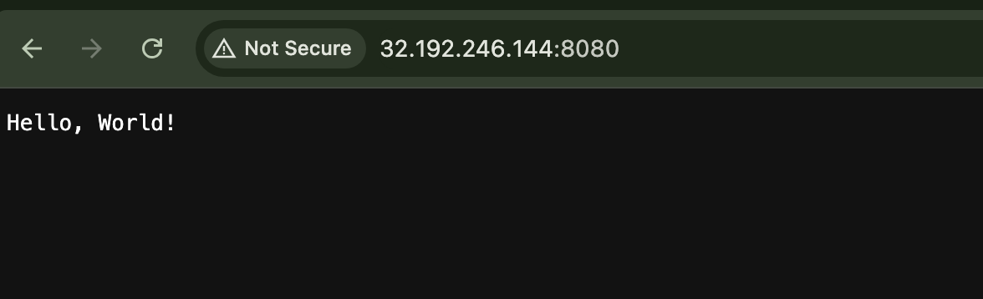
32.192.246.144:8000
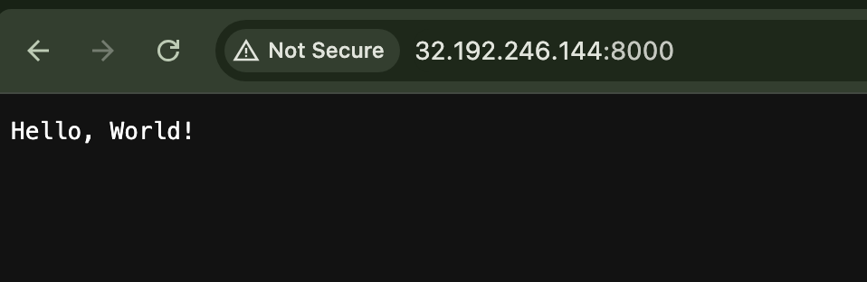
What we did in the above and what change did we cause by doing the change

 | old | new
Nginx role | File server | Reverse proxy
Index.html needed? | Yes | No
port 8080 shows | Static HTML | Docker app response

- Configure to Save the Logs in the location /var/log/cb.log

What are we doing?
We are telling the Docker container to save its application logs to a file called cb.log inside /var/log/ on the EC2 host machine.

Why are we doing it?
Right now the Docker app logs exist only inside the container. This means:
- If the container crashes or restarts, logs are lost
- You can only see logs by running docker compose logs
- No permanent record of what the app did
By saving to /var/log/cb.log on the host:
- Logs persist even if container dies
- You can check logs anytime with cat /var/log/cb.log
- Easier to debug production issues
- Standard practice in real DevOps environments

How is it being done?
Docker has a feature called log driver — it controls where container logs go. We use a json-file log driver with a specific path, OR we use a simpler approach — volume mounting the log file from host into container.
The simplest and most reliable way is to redirect docker compose logs output to the file, OR use Docker's logging configuration in docker-compose.yml.
We will use Docker logging driver in docker-compose.yml and then redirect logs to /var/log/cb.log using a log shipper command in userdata.

The changes done in userdata.sh
logging:
driver: "json-file"
Options:
max-size: "10m"
max-file: "3"
volumes:
- /var/log:/var/log ⇒ This should be added below docker-compose.yml after restart: unless-stopped
And we will also add after step 7 and in before DONE

echo "=== Step 8: Stream container logs to /var/log/cb.log ===" # Create the log file first touch /var/log/cb.log chmod 644 /var/log/cb.log # Stream logs continuously in background nohup docker compose logs -f --no-color >> /var/log/cb.log 2>&1 &

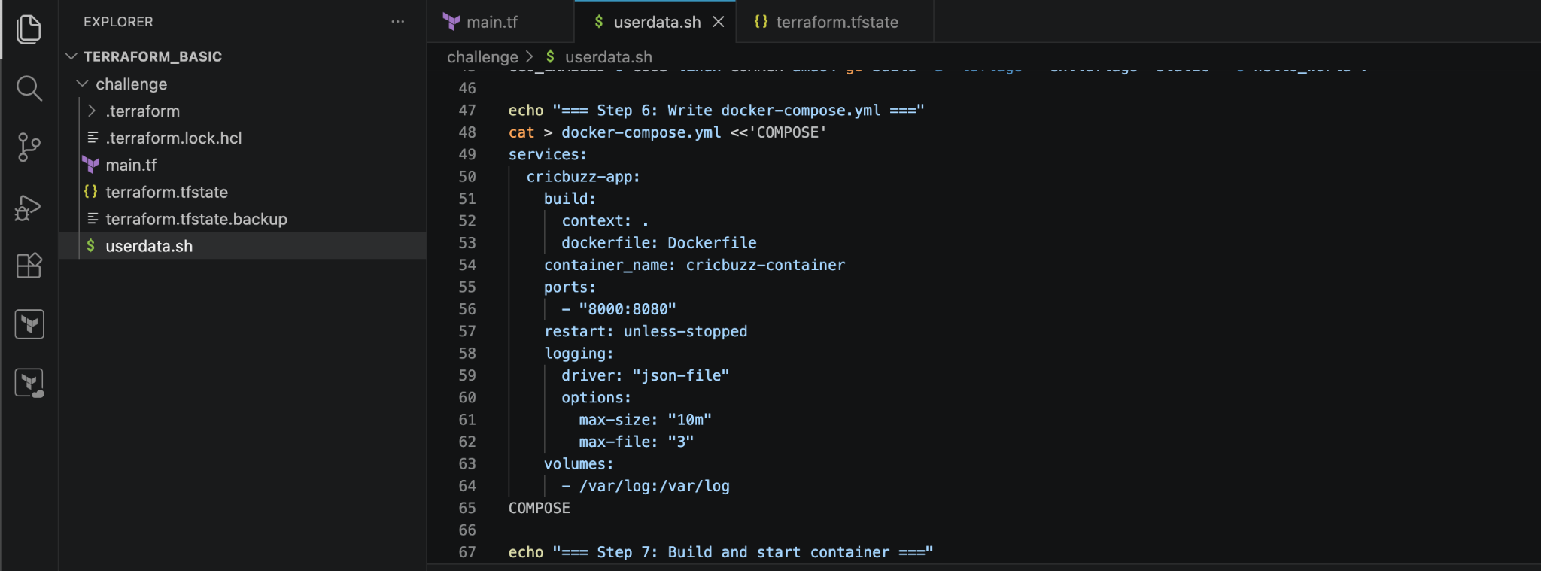
logging driver json-file — tells Docker to store logs in JSON format
max-size 10m — each log file max 10MB so disk doesn't fill up
max-file 3 — keep only 3 log files at a time
volumes /var/log:/var/log — mounts the host's /var/log folder into the container so the app can write directly to it

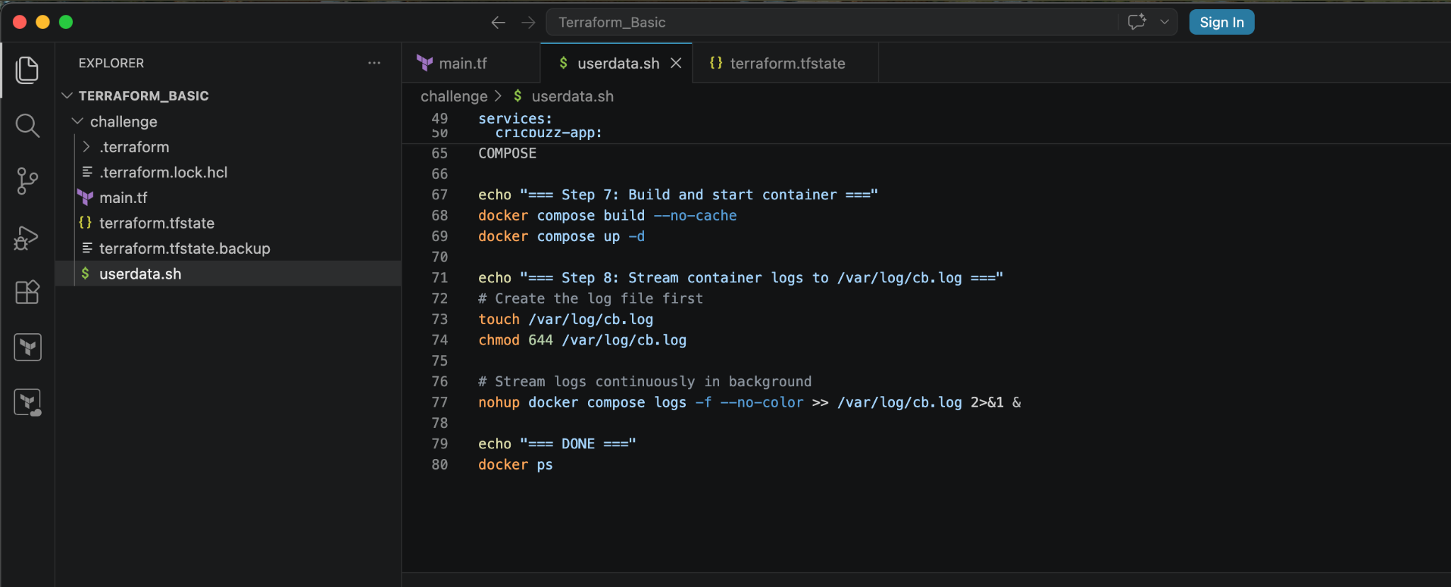
docker compose logs -f — follow/stream logs in real time (like tail -f)
--no-color — removes color codes so the file is clean text
>> /var/log/cb.log — append all logs to cb.log
nohup ... & — run in background so it keeps running even after script finishes

terraform apply
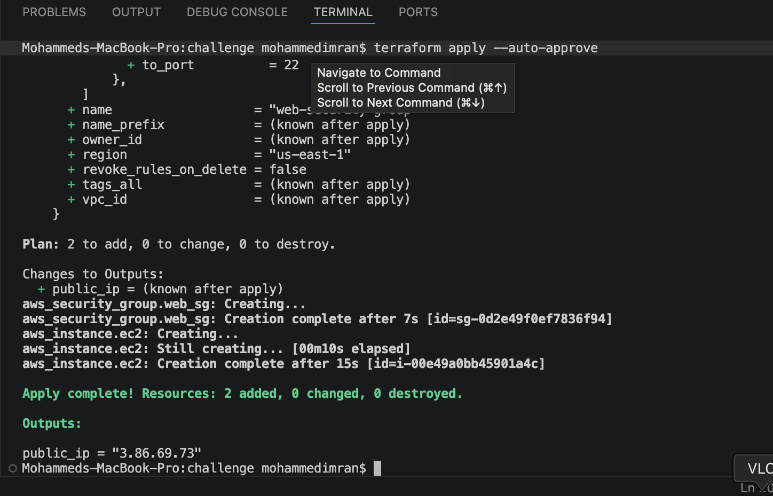
Lets check in ec2 connect if the logs are working or not and stored in the folder we created
For that using command
cat /var/log/cb.log ← Check logs are being saved
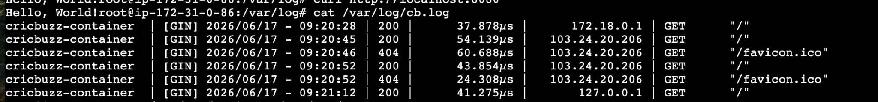
For watching the logs in real time we can use command
tail -f /var/log/cb.log ← Watch logs live in real time by visiting the ip address or using curl will generate a log entry by hitting the app
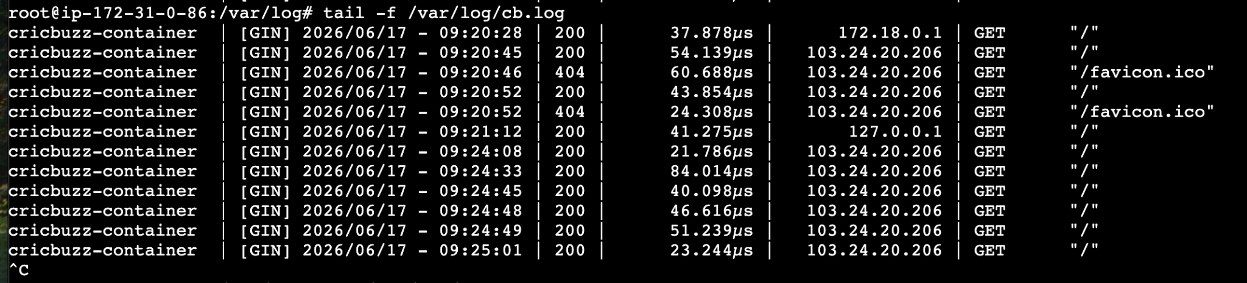
Check again → cat /var/log/cb.log
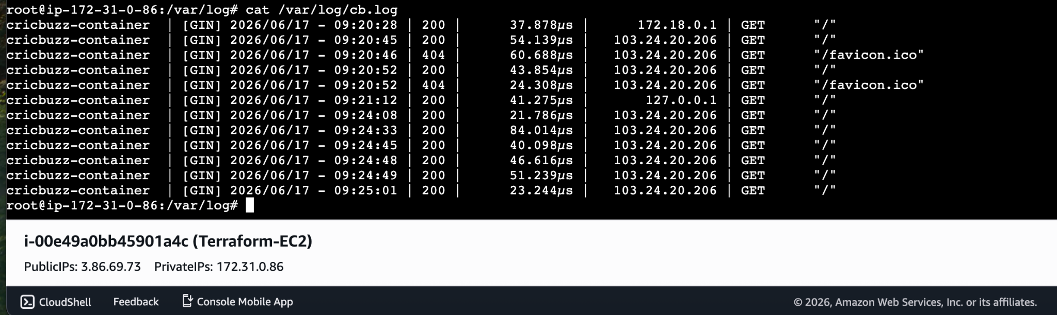

- Write the Log rotate configuration for the above file
Log rotation is automatically managing log files so they don't grow forever and fill up your disk.
Without using this the logs gets piled up and can fill up the disk and cause server failure.
By using logrotate we have daily fresh logs and other logs will be stored and we can set the older logs to be deleted.
Linux has a built-in tool called logrotate. Just write a config file telling it the rules like below
We will add this file in userdata.sh as the last step

echo "=== Step 9: Configure log rotation for cb.log ==="
cat > /etc/logrotate.d/cb <<'EOF'
/var/log/cb.log {
Su root root
daily
rotate 7
compress
delaycompress
missingok
notifempty
copytruncate
dateext
dateformat -%Y-%m-%d
create 644 root root
}
EOF
echo "=== Log rotation configured ==="

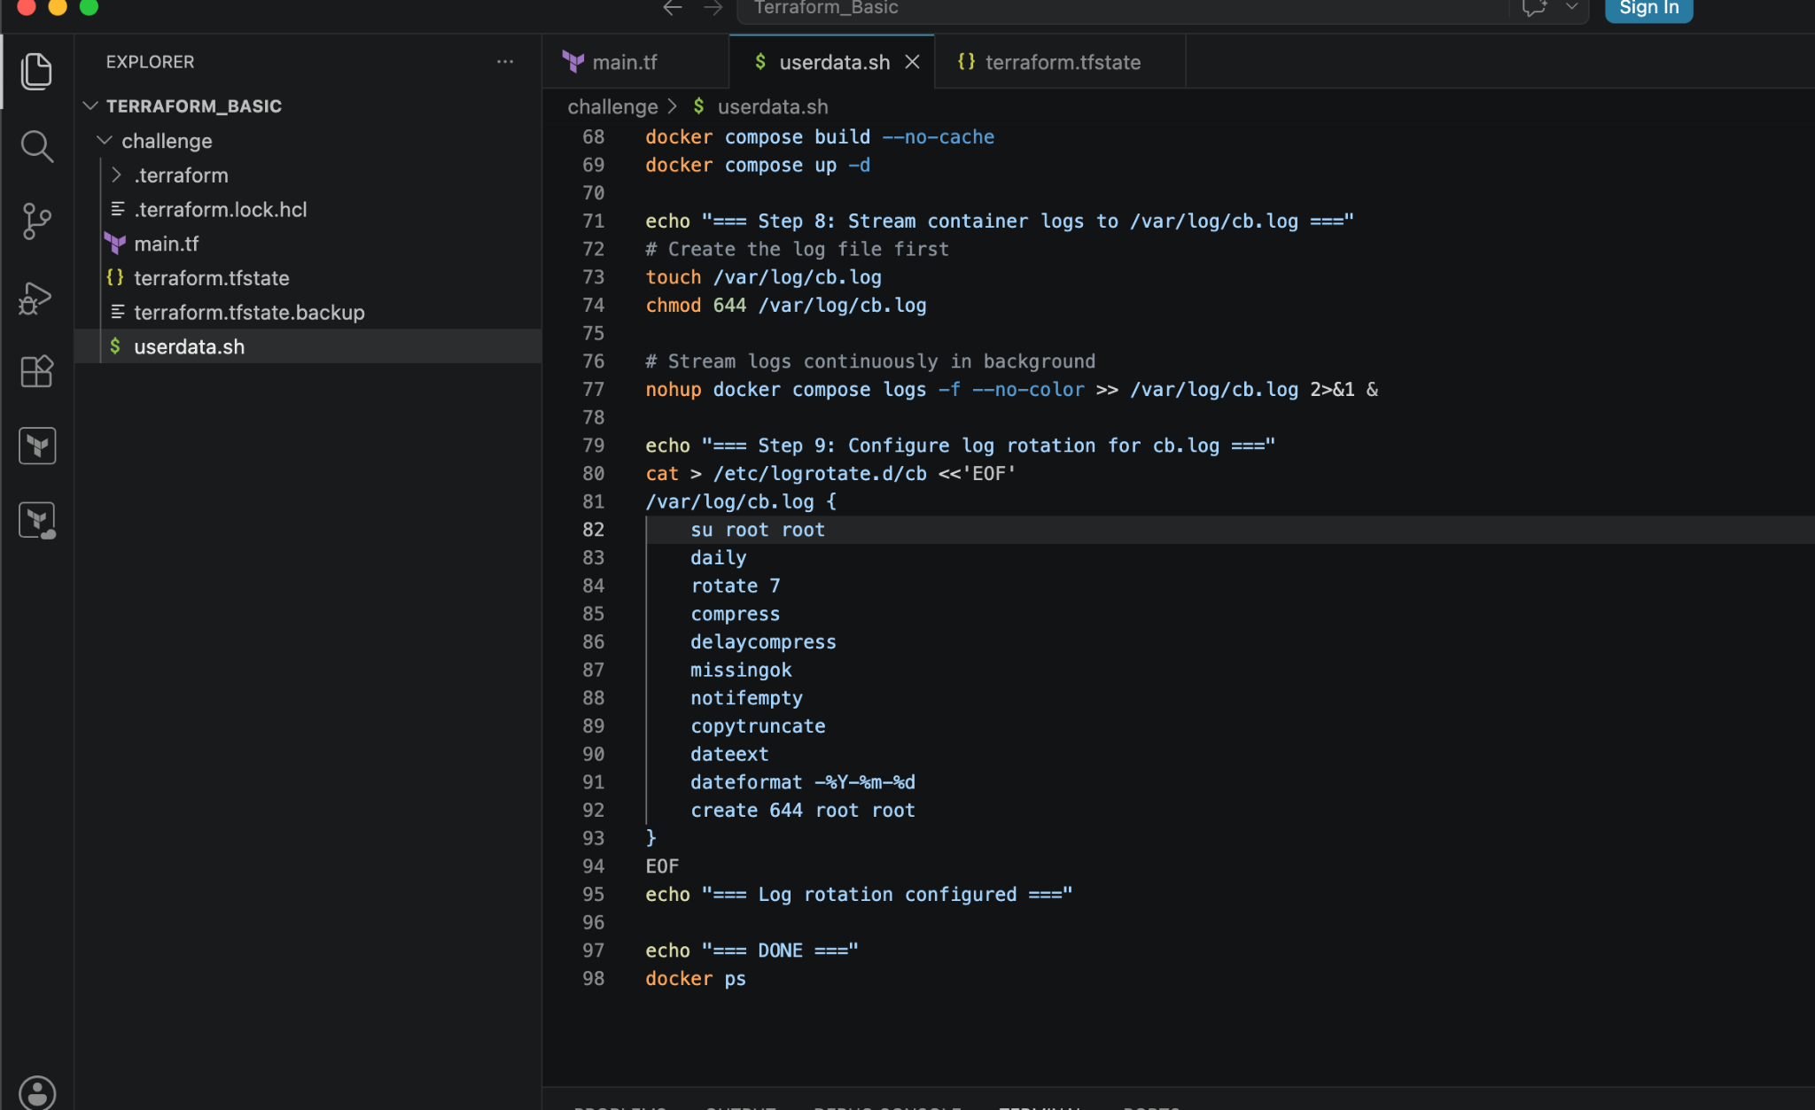

/var/log/cb.log # ← which file to rotate
su root root # ← switch user and group
daily # ← rotate every day
rotate 7 # ← keep 7 old copies, delete anything older
compress # ← compress old logs into .gz to save disk space
delaycompress # ← don't compress the most recent rotated file
# (keeps cb.log.1 readable, cb.log.2.gz compressed)
missingok # ← don't throw error if cb.log doesn't exist
notifempty # ← don't rotate if log file is empty
copytruncate # ← copy the log then empty original
# (important! Docker is still writing to cb.log)
dateext # ← add date to rotated filename instead of numbers
dateformat -%Y-%m-%d # ← format: cb.log-2026-06-17.gz
create 644 root root # ← create fresh empty cb.log after rotation

Why copytruncate is Important Here
Without it:
logrotate renames cb.log → cb.log.1
Docker process still writing to old file (cb.log.1)
New cb.log is empty and gets nothing
With copytruncate:
logrotate copies cb.log content → cb.log.1
Then empties cb.log (truncates it)
Docker keeps writing to same cb.log file ✅
Nothing is lost ✅

terraform apply
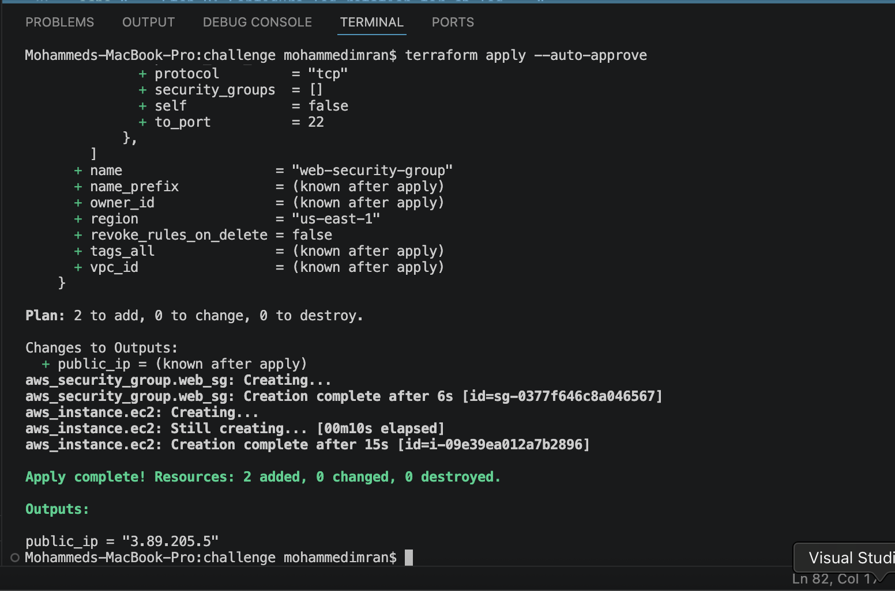
Lets connect to our instance and check if everything is working fine and the logs are getting stored or not

Test if config is valid logrotate --debug /etc/logrotate.d/cb
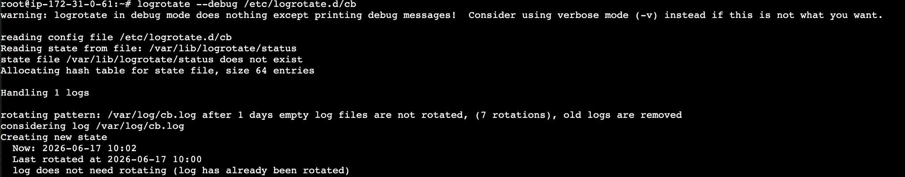
Force rotate right now to verify it works logrotate --force /etc/logrotate.d/cb
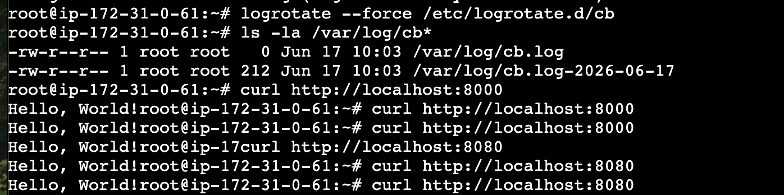
Check result ls -la /var/log/cb* → tar file has been created
Logrotate already runs daily via cron automatically on Ubuntu.
cat /etc/cron.daily/logrotate
